**Operating Systems (CT-353) Lab 02**

**Name:** Ajiya Anwar

**Roll No:** DT-22006

* **First Come First Serve Algorithm (FCFS):**

#include <stdio.h>

struct Process {

int id, at, bt, ct, wt, tat;

};

void swap(struct Process *a, struct Process *b) {

struct Process temp = *a;

*a = *b;

*b = temp;

}

int main() {

int n, i, j, currentTime = 0;

float totalWT = 0, totalTAT = 0;

struct Process p[20];

printf("Enter the number of processes: ");

scanf("%d", &n);

for (i = 0; i < n; i++) {

p[i].id = i + 1;

printf("Enter Arrival Time for Process %d: ", i + 1);

scanf("%d", &p[i].at);

printf("Enter Execution Time (Burst Time) for Process %d: ", i + 1);

scanf("%d", &p[i].bt);

}

// Sort processes by Arrival Time

for (i = 0; i < n - 1; i++) {

for (j = 0; j < n - i - 1; j++) {

if (p[j].at > p[j + 1].at) {

swap(&p[j], &p[j + 1]);

}

}

}

// Calculate Completion Time, Turnaround Time, and Waiting Time

for (i = 0; i < n; i++) {

if (currentTime < p[i].at) {

currentTime = p[i].at; // Idle time if process arrives later

}

p[i].ct = currentTime + p[i].bt; // Completion Time

currentTime = p[i].ct;

p[i].tat = p[i].ct - p[i].at; // Turnaround Time = CT - AT

p[i].wt = p[i].tat - p[i].bt; // Waiting Time = TAT - BT

totalWT += p[i].wt;

totalTAT += p[i].tat;

}

printf("\nPROCESS\tARRIVAL TIME\tEXECUTION TIME\tCOMPLETION TIME\tWAITING TIME\tTURNAROUND TIME\n");

for (i = 0; i < n; i++) {

printf("P%d\t\t%d\t\t%d\t\t%d\t\t%d\t\t%d\n",

p[i].id, p[i].at, p[i].bt, p[i].ct, p[i].wt, p[i].tat);

}

printf("\nAverage Waiting Time: %.2f", totalWT / n);

printf("\nAverage Turnaround Time: %.2f\n", totalTAT / n);

return 0;

}

**Output:**

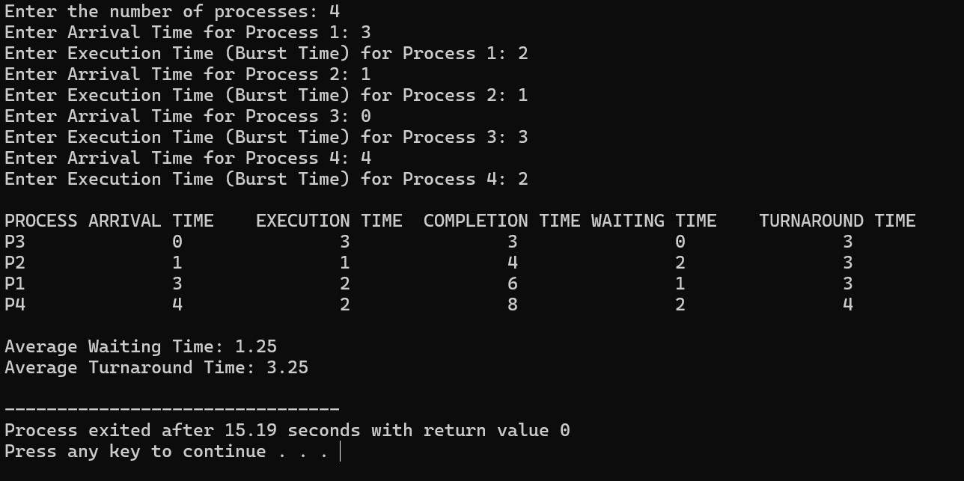

* **Shortest Job First Algorithm(SJF):**

#include <stdio.h>

#include <stdbool.h>

struct Process {

int id, at, bt, ct, wt, tat; // Process attributes

bool completed; // To mark if the process is completed

};

void sortByArrival(struct Process p[], int n) {

int i, j;

for (i = 0; i < n - 1; i++) {

for (j = 0; j < n - i - 1; j++) {

if (p[j].at > p[j + 1].at) {

struct Process temp = p[j];

p[j] = p[j + 1];

p[j + 1] = temp;

}

}

}

}

int main() {

int n, i, completedCount = 0, currentTime = 0;

float totalWT = 0, totalTAT = 0;

struct Process p[20];

printf("Enter the number of processes: ");

scanf("%d", &n);

for (i = 0; i < n; i++) {

p[i].id = i + 1;

printf("Enter Arrival Time for Process %d: ", i + 1);

scanf("%d", &p[i].at);

printf("Enter Execution Time (Burst Time) for Process %d: ", i + 1);

scanf("%d", &p[i].bt);

p[i].completed = false; // Mark as incomplete

}

// Sort processes by Arrival Time

sortByArrival(p, n);

while (completedCount < n) {

int shortestIndex = -1;

int minBurstTime = 9999;

// Find the shortest process that has arrived

for (i = 0; i < n; i++) {

if (!p[i].completed && p[i].at <= currentTime && p[i].bt < minBurstTime) {

minBurstTime = p[i].bt;

shortestIndex = i;

}

}

if (shortestIndex != -1) {

// Process the shortest job

currentTime += p[shortestIndex].bt;

p[shortestIndex].ct = currentTime; // Completion Time

p[shortestIndex].tat = p[shortestIndex].ct - p[shortestIndex].at; // Turnaround Time

p[shortestIndex].wt = p[shortestIndex].tat - p[shortestIndex].bt; // Waiting Time

p[shortestIndex].completed = true;

totalWT += p[shortestIndex].wt;

totalTAT += p[shortestIndex].tat;

completedCount++;

} else {

// If no process is ready, increment the current time

currentTime++;

}

}

// Display Results

printf("\nPROCESS\tARRIVAL TIME\tEXECUTION TIME\tCOMPLETION TIME\tWAITING TIME\tTURNAROUND TIME\n");

for (i = 0; i < n; i++) {

printf("P%d\t\t%d\t\t%d\t\t%d\t\t%d\t\t%d\n",

p[i].id, p[i].at, p[i].bt, p[i].ct, p[i].wt, p[i].tat);

}

printf("\nAverage Waiting Time: %.2f", totalWT / n);

printf("\nAverage Turnaround Time: %.2f\n", totalTAT / n);

return 0;

}

**Output:**

